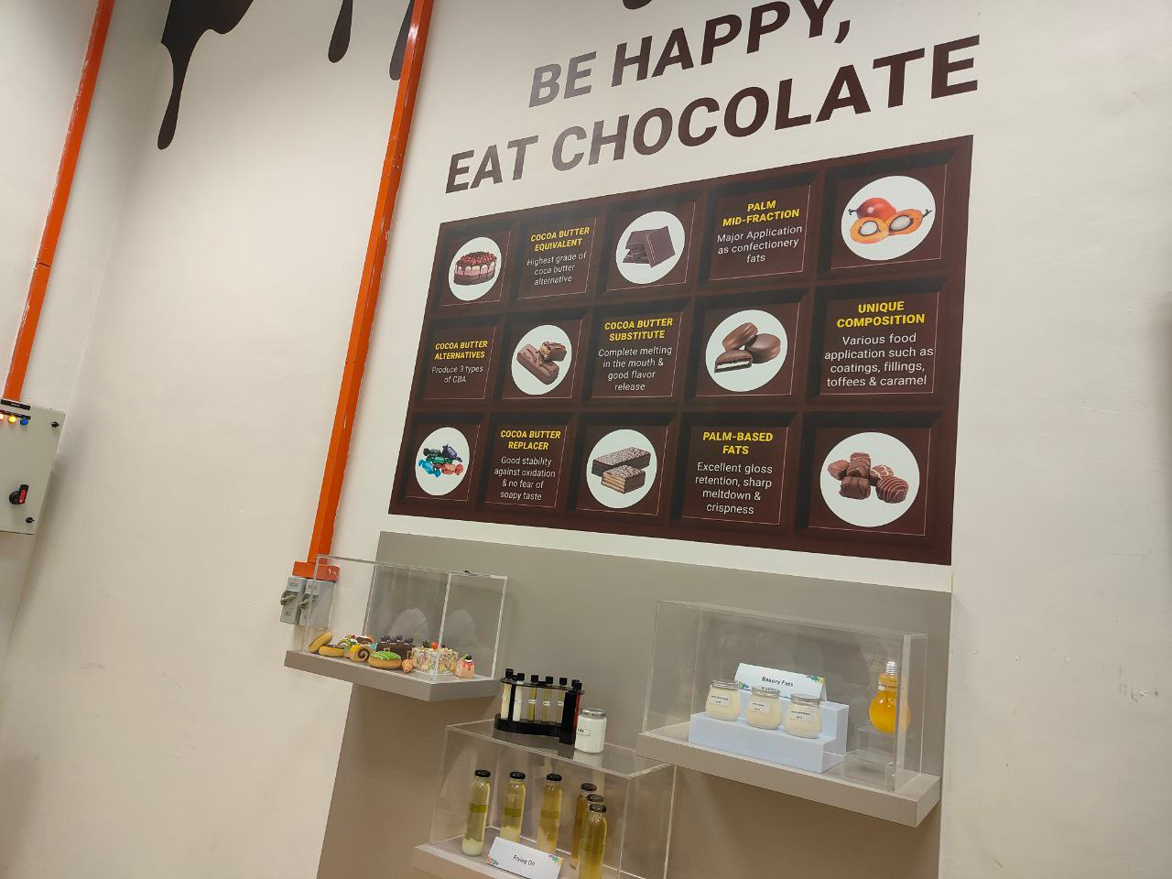

For this industry visit, we can know that the oil palm can do many things such as doing the healthy cooking oil, making ice cream and cookies or cake. Not only that the oil palm also can use its kernel to do the cocoa butter replacer. How we can say that, since many of the markets sells the cheaper chocolates which are using the oil palm to do it because the cocoa butter is too expensive so they try to using something to replace it. Using the oil palm to do the chocolate will completely melt in your mouth, having major application as confectionery fat and excellent gloss retention and crispness. For the cooking oil, the first filter of the oil palm which will pack in the plastic bag. This will be the best oil to fry like chicken, banana, potato and more. The second filter of the oil palm will pack to the bottle one since it is clearer then the first one and make for our home cooking oil. They say that the cooking oil is more healthy than other such as soybean, sunflower and more. Meanwhile, the oil palm can make the CBA which can do cake, cookies and more. When we make the cookies by using the CBA, this can let the cookies more crispness and smooth. Since the CBA cannot sold in the market, so many people don’t know what is it because this only can order by the bakeries. Other than that, the oil palm also can used in the ice cream. For example, McDonald’s will using this to make the ice cream more smooth and easy to melt in the mouth.

In the nutshell, our country is having the best quality of the oil palm and export it over the country which try to let the consumers having the healthy diet since many of the food will using the oil palm to do it.